**REAL-TIME RIVER WATER QUALITY MONITORING AND CONTROL SYSTEM**

**SPRINT-2**

**PYTHON SOURCE CODE-OUTPUT:**

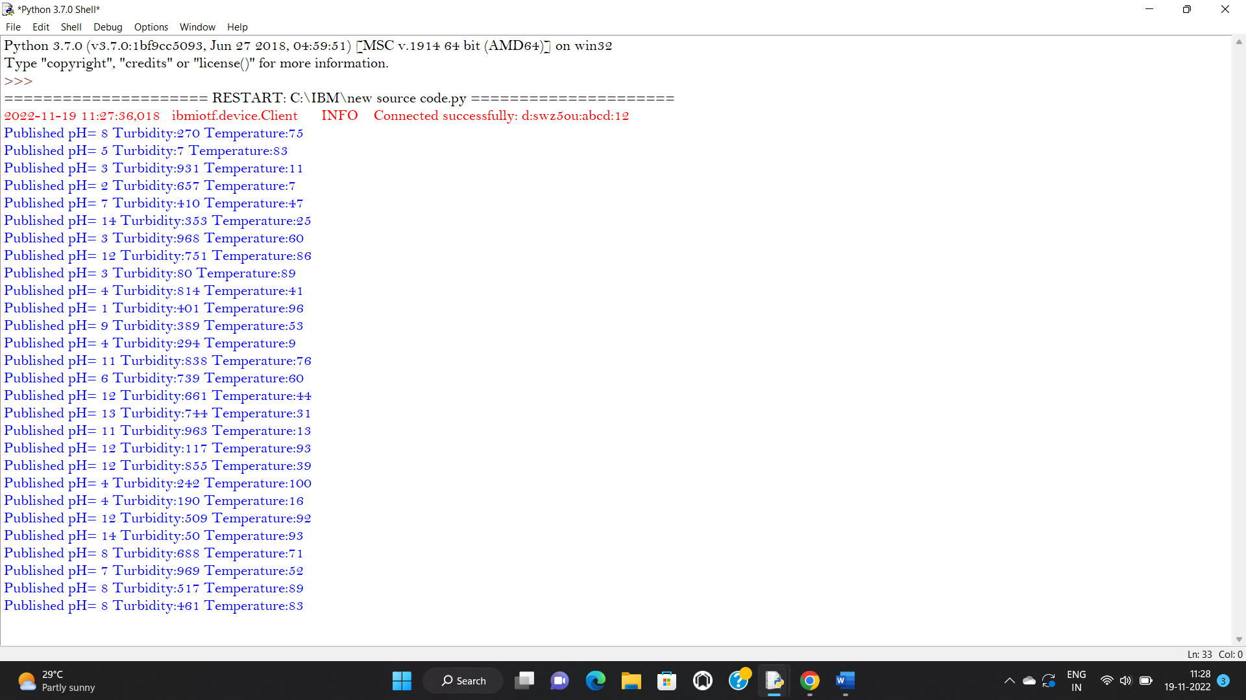

**IBM IOT WATSON:**

